Week 1 Report: Strategic Planning and Data Exploration in Logistics
Prepared by: Sarnadip | Logistics Data Analyst Intern | Week 1

1. Project Scenario
A logistics company delivers about 25,000 packages across five regions of India (north, south, east, west and central). It uses different delivery partners, vehicles and delivery modes (standard, two day, same day and express). About 1 in 4 deliveries arrives late, and some deliveries fail completely. The company wants to understand why deliveries are delayed, and how to reduce delays while keeping delivery cost under control.
The analysis in this report uses a public dataset from Kaggle, Delivery_Logistics.csv, which has 25,000 deliveries and 15 columns: delivery partner, package type, vehicle type, delivery mode, region, weather condition, distance, package weight, delivery time, expected time, delayed (yes or no), delivery status, customer rating and delivery cost. The dataset has no missing values.

2. Key Performance Indicators (KPIs)
A KPI is a number that is tracked to check whether the business is doing well. This project uses four KPIs.
KPI | What it means | Value
On-time delivery rate | Percentage of deliveries that arrive on time | 73.3%
Average delivery cost | Average money spent per delivery | ₹865
Average delivery rating | Average customer rating out of 5 | 3.67
Failed delivery rate | Percentage of deliveries that failed | 5.3%
About 26.7% of deliveries are late, so on-time delivery and cost are the two most important KPIs for the company to improve.

3. Background Research
Why logistics matters in India. Logistics means moving goods from sellers to customers: transport, storage and delivery. A recent NCAER study estimated India's total logistics cost for 2023-24 at 7.97% of GDP. Older figures were higher, and commonly quoted numbers of 13-14% of GDP came from external studies or partial data. The exact number is debated, but logistics is clearly a big and costly part of the economy.
The last-mile problem. The last mile is the final step, from the local hub to the customer's door. Indian e-commerce was expected to grow about 27% a year, which has increased the demand for efficient last-mile delivery. One report from the Capgemini Research Institute says last-mile delivery makes up 41% of total supply chain costs. This is why delays and delivery cost are good topics to analyze.
What drives cost and delays. The NCAER report names fuel, congestion and heavy reliance on trucks as the main cost drivers, with fuel alone making up 42.1% of road freight expenses. Other sources mention traffic, poor road networks and address mapping problems in cities. The dataset supports this idea, because distance (a stand-in for fuel and travel) decides almost all of the delivery cost.
How data science helps. Companies already use data to improve delivery. For example, the Indian logistics startup Rivigo uses AI and big data to optimize routes and reduce delivery times. Three simple data science ideas are used in this project:
- Regression: predict delivery cost from distance.
- Clustering: group similar deliveries (short, medium and long) to plan vehicles and pricing.
- Optimization: find better routes or delivery modes to reduce delay and cost.

4. Project Objectives
Main objective: To use Python and data science to understand why deliveries are delayed and what decides delivery cost, so that a logistics company can improve its service and control its spending.
Specific objectives:
- Measure performance. Calculate the KPIs: on-time delivery rate, average delivery cost, average customer rating and failed delivery rate.
- Find the causes of delays. Compare delay rates across delivery mode, partner, region and weather to see what affects late deliveries the most.
- Understand delivery cost. Check how distance and package weight affect cost, and build a simple regression model to predict cost.
- Group similar deliveries. Use clustering to sort deliveries into short, medium and long groups, which helps with planning vehicles and pricing.
- Suggest improvements. Use the findings to recommend actions, such as giving more attention to express and same day deliveries.

5. Strategic Roadmap
The analysis follows six steps, from raw data to final recommendations.
Step | What we do | Python tool | Example from this project
1. Data collection | Download a public logistics dataset | pandas | Delivery_Logistics.csv with 25,000 deliveries
2. Data cleaning | Fix wrong formats, check for missing values and duplicates | pandas | Converted the time columns into plain hours
3. Exploratory analysis | Calculate KPIs, compare groups and draw charts | pandas, matplotlib | Delay rate by delivery mode
4. Predictive modeling | Predict cost with regression and group deliveries with clustering | scikit-learn | Cost predicted from distance (R2 = 0.98)
5. Optimization (next step) | Use the findings to choose better delivery modes or routes | scipy or similar tools | Reduce delays in express and same day deliveries
6. Reporting | Summarize results and recommend actions | Jupyter Notebook, Word | This report
Why this order works. Clean data comes first, because wrong data gives wrong answers. Exploration comes before modeling, because it shows which patterns are worth modeling. The final step turns numbers into decisions a company can use.
Feasibility. The whole plan uses free tools (Python and Jupyter) and a public dataset, so one analyst can complete it without special resources.

6. Code Illustrations and Results
The code below was run in a Jupyter Notebook on the dataset. Each part shows the code and the result it gave.

6.1 Load and clean the data
The two time columns were stored as dates such as 1970-01-01 00:00:00.000000008. The last digits are the real hours, so the code keeps only those digits and turns them into numbers.
import pandas as pd
df = pd.read_csv("Delivery_Logistics.csv")
# Fix the time columns: the last digits are the hours
df["delivery_time_hours"] = df["delivery_time_hours"].str[-9:].astype(int)
df["expected_time_hours"] = df["expected_time_hours"].str[-9:].astype(int)
print(df.shape)
df.head()
Result: the data has 25,000 rows and 15 columns, and the time columns now show plain hours such as 8, 2 and 10.

6.2 Calculate the KPIs
# KPI 1: On-time delivery rate (%)
on_time_rate = (df["delayed"] == "no").mean() * 100
# KPI 2: Average delivery cost
avg_cost = df["delivery_cost"].mean()
# KPI 3: Average delivery rating
avg_rating = df["delivery_rating"].mean()
# Extra KPI: Failed delivery rate (%)
failed_rate = (df["delivery_status"] == "failed").mean() * 100
print("On-time delivery rate:", round(on_time_rate, 1), "%")
print("Average delivery cost:", round(avg_cost, 0))
print("Average rating:", round(avg_rating, 2))
print("Failed delivery rate:", round(failed_rate, 1), "%")
Result:
KPI | Value
On-time delivery rate | 73.3%
Average delivery cost | ₹865
Average delivery rating | 3.67 / 5
Failed delivery rate | 5.3%
Insight: About 1 in 4 deliveries (26.7%) arrives late, and 5.3% of deliveries fail completely. The company can improve its service by finding out what causes these delays.

6.3 Delay rate by delivery mode
# Delay rate (%) for each delivery mode
delay_by_mode = (df["delayed"] == "yes").groupby(df["delivery_mode"]).mean() * 100
print(delay_by_mode.round(1))
Result:
Delivery mode | Delay rate
Express | 73.8%
Same day | 32.5%
Two day | 0.4%
Standard | 0.0%
Insight: Express deliveries are delayed the most (about 3 in 4), followed by same day deliveries. Standard and two day deliveries are almost never late. The faster the promised delivery, the harder it is to deliver on time.

6.4 How distance and weight affect cost
print(df[["distance_km", "package_weight_kg", "delivery_cost"]].corr().round(2))
Result:
Pair | Correlation
Distance and cost | 0.99
Weight and cost | 0.10
Distance and weight | 0.00
Insight: A correlation close to 1 means two things move together. Delivery cost is almost fully decided by distance, while package weight has only a very small effect.

6.5 Predict delivery cost (regression)
from sklearn.linear_model import LinearRegression
# Input (X) and the thing we want to predict (y)
X = df[["distance_km"]]
y = df["delivery_cost"]
# Train the model
model = LinearRegression()
model.fit(X, y)
# Predict the cost of a 100 km delivery
prediction = model.predict(pd.DataFrame({"distance_km": [100]}))
print("Cost for 100 km:", round(prediction[0], 0))
print("Accuracy score (R2):", round(model.score(X, y), 2))
Result:
Result | Value
Predicted cost for a 100 km delivery | ₹613
Accuracy score (R2) | 0.98
Insight: A simple regression model can predict delivery cost from distance alone with 98% accuracy. This helps a company estimate the price of a delivery before it is made and plan its budget.

6.6 Group similar deliveries (clustering)
from sklearn.cluster import KMeans
# Group deliveries by distance and weight
X = df[["distance_km", "package_weight_kg"]]
model = KMeans(n_clusters=3, random_state=42, n_init=10)
df["group"] = model.fit_predict(X)
# See what each group looks like
print(df.groupby("group")[["distance_km", "package_weight_kg", "delivery_cost"]].mean().round(1))
Result:
Group | Type | Average distance | Average weight | Average cost
1 | Short deliveries | 51 km | 25 kg | ₹369
0 | Medium deliveries | 152 km | 25 kg | ₹874
2 | Long deliveries | 251 km | 25 kg | ₹1,369
Insight: The deliveries naturally split into three groups: short, medium and long. The groups differ mostly by distance, and the average cost rises with each one. A company could use these groups to plan vehicles, set prices and assign delivery partners.

6.7 Chart of delays by delivery mode
import matplotlib.pyplot as plt
delay_by_mode = (df["delayed"] == "yes").groupby(df["delivery_mode"]).mean() * 100
delay_by_mode.plot(kind="bar", color="steelblue")
plt.title("Delay Rate by Delivery Mode")
plt.ylabel("Delayed deliveries (%)")
plt.xlabel("Delivery mode")
plt.show()
Result: the bar chart shows express deliveries with the tallest bar (about 74%), same day at about 32%, and standard and two day close to zero.
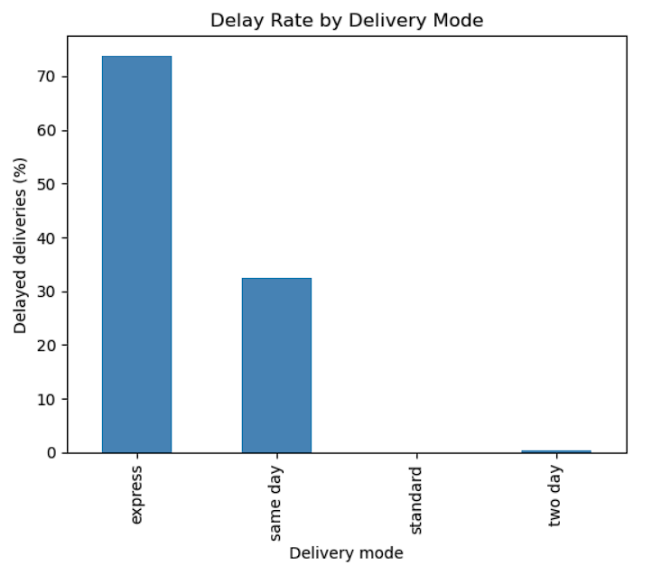

6.8 Optimization (planned next step)
Optimization is planned for the next stage and was not run in Week 1. The idea is to use the findings to reduce delays and cost, for example by setting more realistic promised times for express and same day deliveries, or by using the distance groups to choose the right vehicle for each delivery. A tool such as scipy can be used to search for the lowest-cost plan.

7. Conclusion
What the analysis found:
- About 73.3% of deliveries arrive on time, so 26.7% are late, and 5.3% fail.
- Delivery mode is the clearest factor behind delays. Express (73.8%) and same day (32.5%) deliveries are late far more often than standard and two day deliveries.
- Delivery cost is almost fully decided by distance (correlation 0.99), and a simple regression model predicts cost with an R2 of 0.98.
- Clustering splits deliveries into short, medium and long groups with clearly different costs.
Expected outcomes and impact on decisions:
- Better promises to customers. The company can review the time it promises for express and same day deliveries, since these are late most often.
- Better budgeting. The cost prediction model lets the company estimate the price of a delivery before it happens.
- Better planning. The distance groups can guide the choice of vehicles, pricing and delivery partners.
- Next steps. Build a model to predict which deliveries are likely to be late, and add the optimization step to find lower-cost delivery plans.
Limitations. The delivery_id column in the dataset is messy and was not used. The delay rate also changed very little between partners and regions, so these were less useful for explaining delays in this dataset.

References
- NCAER, "Assessment of Logistics Cost in India" (2023-24), as reported by itln.in and Outlook Business.
- Drishti IAS, "Transforming India's Logistics Landscape" (1 October 2024).
- Civilsdaily, "Revamping Logistics: What's Holding Back India's Story".
- kundanbedmutha, "Delivery Logistics Dataset (India – Multi-Partner)", Kaggle, 25,000 deliveries: Kaggle dataset page

